
PB1/PHQP/1223/A 05-DEC-2023
PRE BOARD EXAMINATION – I (2023-24)
Subject: PHYSICS  Grade: XII |  | Max. Marks: 70  Time: 3Hrs
Name: |  | Section: |  |  | Roll No:
General Instructions:
- There are 33 questions in all. All questions are compulsory.
- This question paper has five sections: Section A, Section B, Section C, Section D and Section E.
- All the sections are compulsory.
- Section A contains sixteen questions, twelve MCQ and four Assertion Reasoning based of ONE mark each, Section B contains five questions of TWO marks each, Section C contains seven questions of THREE marks each, Section D contains two case study based questions of FOUR marks each and Section E contains three long answer questions of FIVE marks each.
- There is no overall choice. However, an internal choice has been provided in one question in Section B, one question in Section C, one question in Section D and all three questions in Section E. You have to attempt only one of the choices in such questions.
- Use of calculators is not allowed.
- You may use the following values of physical constants where ever necessary
  - c = 3 x 108 m/s
  - me = 9.1 x10⁻³¹ kg
  - e = 1.6 x 10-19 C
iv. µ0 = 4π x 10⁻⁷ Tm𝑨^{−𝟏} v. h = 6.63 x10-34 Js
vi. ε0 = 8.854 x10⁻¹² 𝑪^{𝟐}𝑵^{−𝟏}𝒎^{−𝟐}
vii. Avogadro’s number = 6.023 X 𝟏𝟎^{𝟐𝟑} per gram mole
 | SECTION- A
 | A point charge +q is a distance a/2 directly above the centre of a square of side b, as shown in Figure. The magnitude of the electric flux through the square is |  |  | 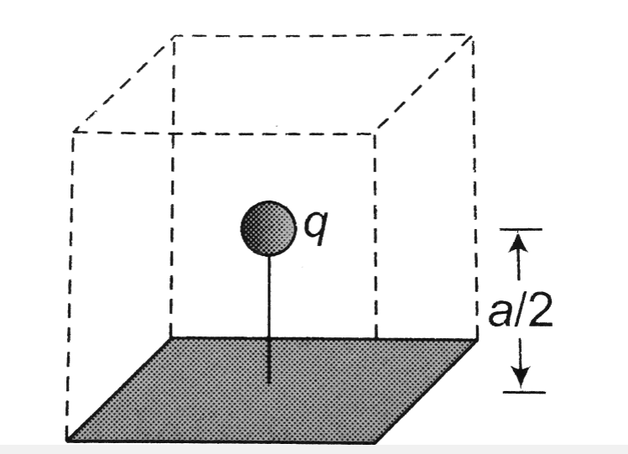 |  | 1
 | a) q/ε₀ |  | b) 2q/aε₀
 | c) qa/2ε₀ |  | d) q/6ε₀
 | A hollow metal sphere of radius 5 cm is charged so that the potential on its surface is 10 V. The potential at the centre of the sphere is |  |  |  |  | 1
 | - 10V |  | - 1V
 | c) 0.1 V |  | d) zero
 | For a cell, the graph between the potential difference (V) across the terminals of the cell and the current (I) drawn from the cell is shown in figure. The emf and the internal resistance of the cell are - |  | 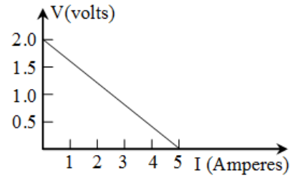 |  |  | 1
 | - 2V, 0.5 Ω |  | - 2V, 0.4 Ω
 | - >2V, 0.5 Ω |  | - >2V, 0.4 Ω
 | An electric dipole is placed in a region of constant electric field E. Which of the following electric dipole is in stable equilibrium ? |  |  |  |  | 1
 | 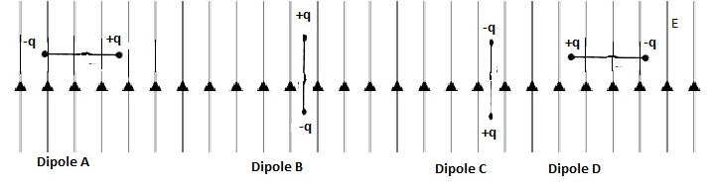
 | - Dipole A |  | - Dipole B
 | - Dipole C |  | - Dipole D
 | The examples of diamagnetic, paramagnetic and ferromagnetic materials are respectively |  |  |  |  | 1
 | a) copper, aluminium, iron |  | b) aluminium, copper, iron
 | c)copper, iron, aluminium |  | d)aluminium, iron, copper
 | A circular coil of area of cross section A carries current of I amperes. The magnet moment M associated with the current loop is |  |  |  |  | 1
 | - IA |  | - I/A
 | - A/I |  | - zero
 | If the number of turns in a moving coil galvanometer of current sensitivity C and voltage sensitivity V is doubled, then |  |  |  |  | 1
 | a) C remains unchanged, but V is doubled |  | b) Both C and V are halved
 | c) Both C and V are doubled |  | d) C is doubled and V remains unchanged
 | - The figure shows the variation of magnetic flux with current for two identical solenoids A and B. One is air cored and the other is iron cored. |  | 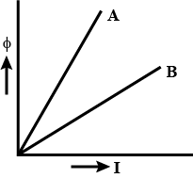 |  |  | 1
 | - A is air cored , B is iron cored. |  | - B is air cored , A is iron cored.
 | - A and B are air cored |  | - A and B are iron cored.
 | In total reflecting prisms are used in periscope , the incident ray
 | - deviates the ray through 90⁰ |  | - deviates the ray through 180⁰
 | - deviates the ray through 60⁰ |  | - Has no deviation
 | Parallel beam of light is incident on a convex lens. The nature of refracted wavefront is |  | 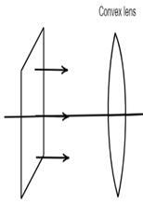 |  |  | 1
 | - Plane wavefront |  | - Spherical wavefront
 | - Cylindrical wavefront |  | - No wavefront
 | If two independent sources have a randomly varying phase difference Φ(t), the resultant intensity will be given by |  |  |  |  | 1
 | a) I₀√2 |  | b) I₀/2
 | c) 2 I₀ |  | d) I₀/√2
 | When an electron jumps from the fourth orbit to the second orbit, one gets the |  |  |  |  | 1
 | a) Second line of Balmer series |  | b) First line of Pfund series
 | c) second line of Paschen series |  | d) Second line of Lyman series
For Questions 13 to 16, two statements are given –one labelled Assertion (A) and other labelled Reason (R). Select the correct answer to these questions from the options as given below.
- If both Assertion and Reason are true and Reason is correct explanation of Assertion.
- If both Assertion and Reason are true but Reason is not the correct explanation of Assertion.
- If Assertion is true but Reason is false.
- If both Assertion and Reason are false.

 | Assertion(A): No work is done in moving a test charge from one point to another over an equipotential surface.  Reason(R): Electric field is always normal to the equipotential surface at every point |  |  |  |  | 1
 | Assertion(A):When two coils are wound on each other, the mutual induction between coil is maximum.  Reason(R): Mutual induction doesn’t depends on the orientation of the coils |  |  |  |  | 1
 | Assertion(A):A variable capacitor is connected in series with a bulb through AC source if the capacitance of variable capacitor is decrease the brightness of bulb is reduced  Reason(R):The reactance of capacitor increase if capacitance is reduced |  |  |  |  | 1
 | Assertion(A): No interference pattern is detected when two coherent sources are infinitely close to each other.  Reason(R): The fringe width is inversely proportional to the distance between the two slits |  |  |  |  | 1
 | SECTION- B
 | Potential difference V is applied across the ends of copper wire of length (l) and diameter D. What is the effect on drift velocity of electrons if (1) V is doubled (2) l is doubled . Justify? |  |  |  |  | 2
 | OR
 | Using Kirchhoff’s rules, find the potential difference between the points A and D in the given circuit so that no current flows through 4 Ω resistance. |  |  | 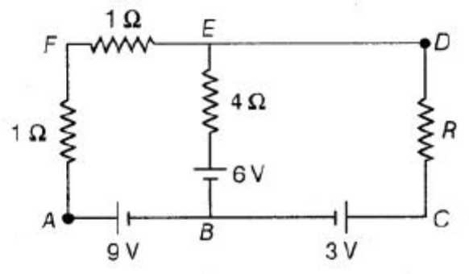
 | State Huygen’s principle. With the help of a suitable diagram, apply this principle to verify laws of refraction. |  |  |  |  | 2
 | Using Bohr’s postulates , obtain the texpression for radius of n^{th} stable orbit in a hydrogen atom. |  |  |  |  | 2
 | Two nuclei A and B of mass numbers are in the ratio 1: 27. What is the ratio of a) the densities and b) the radii of the 2 nuclei? Justify? |  |  |  |  | 2
 | Three students X, Y and Z performed an experiment for studying the variation of alternating currents with angular frequency in a series LCR circuit and obtained the graphs shown below. They all used a.c. sources of the same r.m.s value and inductances of the same value. What can we (qualitatively) conclude about the  a) Capacitance value  b) Resistance values  used by them? Give reason? |  |  | 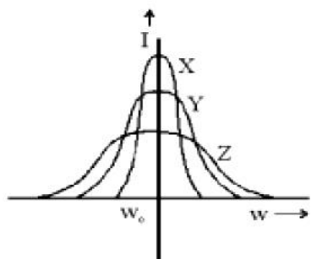 |  | 2
 | SECTION -C
 | A parallel plate capacitor of capacitance C is charged to a potential V by a battery. Without disconnecting the battery, the distance between the plates is doubled and a dielectric medium of k = 10 is introduced between the plates of the capacitor. Explain giving reasons, how will the following be affected :  - capacitance of the capacitor  - charge on the capacitor, and  - energy stored in the capacitor |  |  |  |  | 3
 | When an alternating voltage of 220V is applied across a device X, a current of 0.5 A flows through the circuit and is in phase with the applied voltage. When the same voltage is applied across another device Y, the same current again flows through the circuit but it lead the applied voltage by π/2 radians.  a) Name the device X and Y.  b) Calculate the current flowing in the circuit when same voltage is applied across the serious combination of X and Y |  |  |  |  | 3
 | OR
 | State the principle of a transformer? Name the physical quantity that remains constant in the working of transformer?
 | In the circuit shown in the figure, find the total resistance of the circuit and the current in the arm CD.  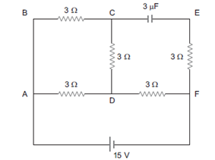 |  |  |  |  | 3
 | b) Sketch the variation of resistivity with temperature for a) conductor, b) Semiconductor?
 | - Draw a schematic sketch of the electromagnetic waves propagating along the +x axis. Indicate the direction of the electric and magnetic fields.  - Electromagnetic waves with wavelength  - λ1 are used to study structure of nuclei  - λ2 are produced by bombarding a metal target by high energy electrons  - λ3 are used for water purification |  |  |  |  | 3
 | The following figure shows the variation of intensity of magnetisation versus the applied magnetic field intensity, H for two magnetic materials A and B.  a) Identify the materials A and B.  (b) Identify the material having negative susceptibility ? Give an example of this material? How does this material vary with temperature? |  | 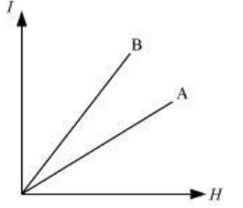 |  |  | 3
 | a) In a single slit diffraction experiment, the width of the slit is made double the original width. How does this affect the size and intensity of the central diffraction band?  b) In Young’s double-slit experiment using monochromatic light of wavelength λ, the intensity of light at a point on the screen where path difference is λ is K units. What is the intensity of light at a point where path difference is λ /3? |  |  |  |  | 3
 | State Bohr’s postulate for the permitted orbits for the electron in a hydrogen atom. Use this postulate to prove that the circumference of the nth permit orbit for the electron can contain exactly n wavelengths of the de-Broglie wavelength associated with the electron in that orbit? |  |  |  |  | 3
 | SECTION -D Case Study Based Questions
Lenz's law states that the direction of induced current in a circuit is such that it opposes the change which produces it. Thus, if the magnetic flux linked with a closed circuit increases, the induced current flows in such a direction that magnetic flux is created in the opposite direction of the original magnetic flux. If the magnetic flux linked with the closed circuit decreases, the induced current flows in such a direction so as to create magnetic flux in the direction of the original flux.
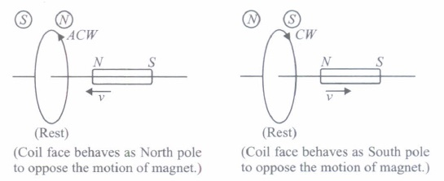
(i) | A square of side L metres lies in the x-y plane in a region, where the magnetic field is given by B =B₀(2i + 3j + 4k) T, where Bo is constant. The magnitude of flux passing through the square is |  |  |  |  | 1
 | (a) 1B_{o}L² Wb. |  |  | (b) 2B_{o}L² Wb.
 | (c) 3B_{o}L² Wb. |  |  | (d) 4B_{o}L² Wb.
(ii) | The polarity of induced emf is given by |  |  |  |  | 1
  (a) Ampere's circuital law | (b) Biot-Savart law
  (c) Lenz's law | (d) Fleming's right hand rule
(iii) | Lenz's law is a consequence of the law of conservation of |  |  |  |  | 1
  (a) charge | (b) mass | (c) momentum | (d) energy
(iv) | Near a circular loop of conducting wire as shown in the figure, an electron moves uniformly along a straight line. The direction of the induced current if any in the loop is  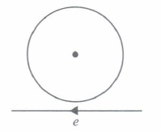 |  |  |  |  | 1
  (a) variable | (b) clockwise
  (c) anticlockwise | (d) zero
 | OR
(iv) | A rectangular loop is being pulled at a constant speed v, through a region of certain thickness d, in which a uniform magnetic field B is set up.The grpah between position x of the right hand edge of the loop and the induced emf will be |  |  | 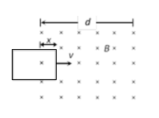
 | a) |  |  | b)
 | 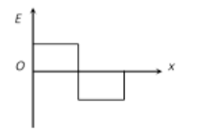 |  |  | 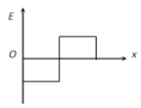
 |  |  |  | d)
 | 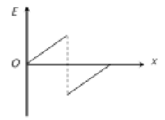 |  |  | 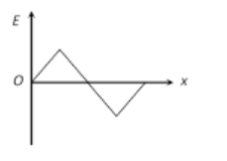
Deviation and Dispersion of light through prism:
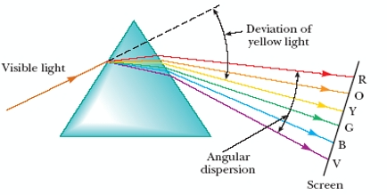
When light passes through a triangular prism it deviates from its original path, deviation of light depends on angle of the prism, refractive index etc. Different colours undergo different deviation which causes dispersion of light when white light passing through prism.

(i) | Identify the colour which has greater refractive index? |  |  |  |  | 1
(ii) | What is the condition for minimum deviation? |  |  |  |  | 1
(iii) | The angle of incidence for a ray of light at a refracting surface of a prism is 45º . The refracting angle of prism is 60º . If the ray suffers minimum deviation through the prism, calculate the angle of minimum deviation ? |  |  |  |  | 2
 | OR
(iii) | The refractive index of the material of a prism is √2 and the angle of the prism is 30º . One of the two refracting surfaces of the prism is made a mirror inwards, by silver coating. A beam of monochromatic light entering the prism from the other face will retrace its path (after reflection from the silvered surface ) Find the angle of incidence on the prism ?
 | SECTION -E
 | a) State Gauss’s law in electrostatics. Apply this law to derive an expression for the electric field intensity at a point due an infinite long line charge of linear charge density λ. |  |  |  |  | 5
 | b)The electrostatic potential V is changing with distance r according to the following graph. Draw the graph for the variation of electric field with distance r. |  | 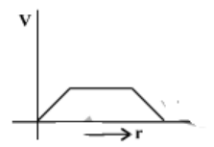
 | OR
 | a) Derive expression for electric field intensity at any point on the equatorial line of an electric dipole?
 | b)What is the angle between the electric dipole moment and net electric field intensity at any point on the equatorial line of the electric dipole?
 | - State the principle of a moving coil galvanometer? Prove that the current flowing through the coil of a moving coil galvanometer is directly proportional to its deflection. |  |  |  |  | 5
 | - Two wires of equal lengths are bent in the form of two loops. One of the loop is square shaped whereas the other loop is circular .These are suspended in a uniform magnetic field and the same current is passed through them. Which loop will experience greater torque? Give reason?
 | OR
 | - State Biot-savart law.Express it in vector form
 | - Two very small identical circular loops, (1) and (2), carrying equal currents I are placed vertically (with respect to the plane of the paper) with their geometrical axes perpendicular to each other as shown in the figure. Find the magnitude and direction of the net magnetic field produced at the point O. |  |  | 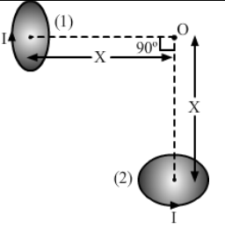
 | - Draw a labelled ray diagram of an astronomical telescope in normal adjustment? |  |  |  |  | 5
 | - A small telescope has an objective lens of focal length 144cm and an eyepiece of focal length 6.0cm. What is the magnifying power of the telescope? What is the separation between the objective and the eyepiece
- You are given the following three lenses. Which lens will you use as an objective to construct an astronomical telescope?
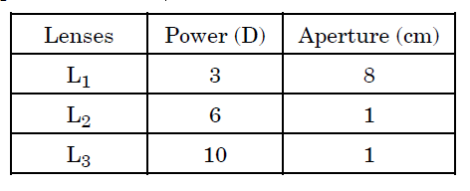
 | OR
- Derive the expression for lens maker’s formula with the help of labelled diagram
- How does the power of a convex lens vary, if the incident red light is replaced by violet light ?
- You are given three lenses L1, L2 and L3 each of focal length 30cm. An object is kept at 60cm in front of L1, as shown. The final real image is formed at the focus ‘I’ of L3. Find the separations between L1, L2 and L3.

  

